Data types categories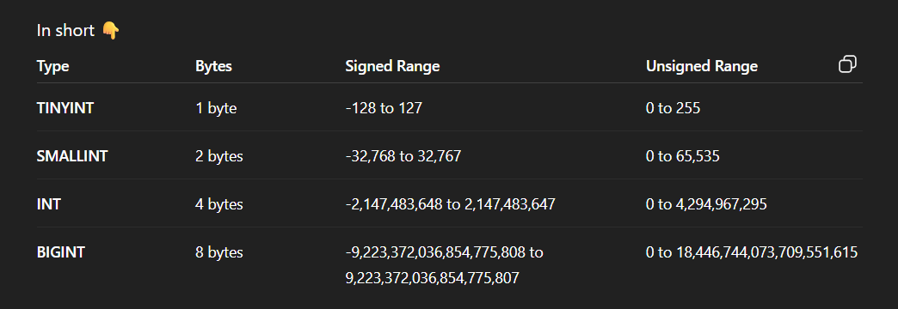
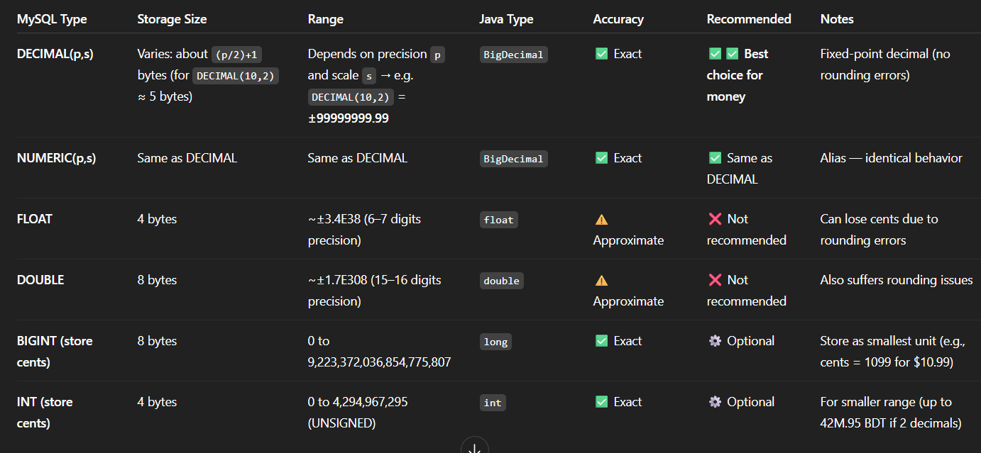
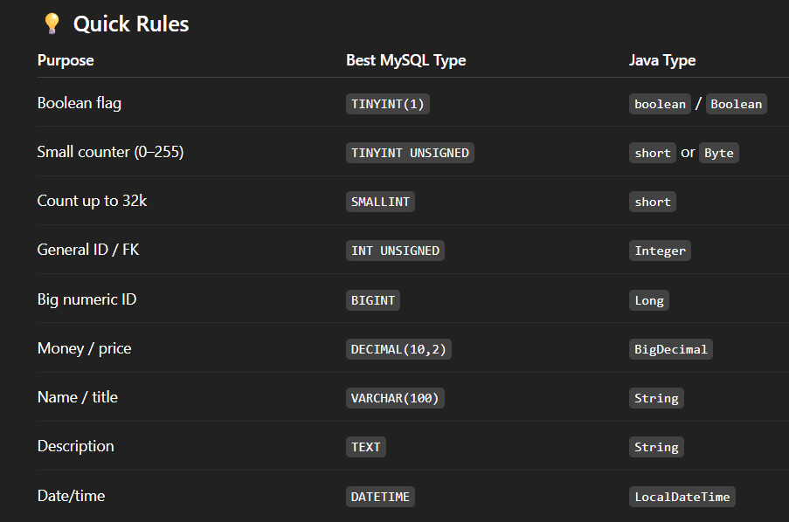
private Integer id; // INT
private Short roomId; // SMALLINT
private Byte status; // TINYINT
private String name; // VARCHAR(100)
private BigDecimal price; // DECIMAL(10,2)
private LocalDateTime added; // DATETIME
private Boolean active; // BOOLEAN
private byte[] image; // BLOB

MySQL Type | Bytes (MySQL) | Java Type (Primitive) | Java Type (Wrapper) | Typical Usage
TINYINT | 1 byte | byte | Byte | Small flags, status, boolean values
BOOLEAN / BOOL | 1 byte | boolean | Boolean | True/false values (stored as TINYINT(1))
SMALLINT | 2 bytes | short | Short | Small numeric IDs, limited range (e.g., room numbers)
MEDIUMINT | 3 bytes | int | Integer | Medium numeric ranges (rarely used)
INT / INTEGER | 4 bytes | int | Integer | Most numeric IDs, counts
BIGINT | 8 bytes | long | Long | Large IDs, timestamps, counters
FLOAT | 4 bytes | float | Float | Small decimal numbers (low precision)
DOUBLE | 8 bytes | double | Double | Larger decimal numbers (higher precision)
DECIMAL(p,s) | variable (≈ 4–16 bytes) | — | BigDecimal | Exact decimal values (money, prices)
CHAR(n) | n bytes (fixed) | — | String | Fixed-length strings (e.g. codes, genders)
VARCHAR(n) | n × char size + 1–2 bytes | — | String | Variable text (names, titles, addresses)
TEXT | up to 65,535 bytes | — | String | Long text (descriptions)
MEDIUMTEXT | up to 16 MB | — | String | Very large text (logs, documents)
LONGTEXT | up to 4 GB | — | String | Extremely large text
DATE | 3 bytes | — | LocalDate | Only date (YYYY-MM-DD)
TIME | 3 bytes | — | LocalTime | Only time (HH:MM:SS)
DATETIME | 5 bytes | — | LocalDateTime | Date + time (no timezone)
TIMESTAMP | 4 bytes | — | LocalDateTime | Date + time (UTC stored)
YEAR | 1 byte | short / Integer | Short / Integer | Year values (e.g. 2025)
BLOB | up to 65 KB | — | byte[] | Binary data (small images/files)
MEDIUMBLOB | up to 16 MB | — | byte[] | Medium-sized binary data
LONGBLOB | up to 4 GB | — | byte[] | Large binary data (videos, big files)
JSON | variable | — | String / JsonNode | JSON documents
ENUM('A','B',...) | 1–2 bytes | — | String / Enum | Categorical values (limited choices)

How to drop Constraint/ Foreign Key
ALTER TABLE table_name
DROP FOREIGN KEY constraint_name;

How to add Constraint/ Foreign Key
ALTER TABLE child_table// the current table, where u want to add the key in
ADD CONSTRAINT fk_name// constrain name
FOREIGN KEY (child_column)//the column of current table that u want to add key on
REFERENCES parent_table(parent_column)//the table and (tables column) u want to add here
ON DELETE CASCADE
ON UPDATE CASCADE;// if needed
EX:
ALTER TABLE refresh_tokens
ADD CONSTRAINT items_ibfk_1
FOREIGN KEY (user_id)
REFERENCES users(id)
ON DELETE CASCADE;

How to update data type of a column
ALTER TABLE table_name
MODIFY column_name targeted_type UNSIGNED NOT NULL/ DEFULT NULL;
EX: ALTER TABLE refresh_tokens MODIFY user_id BIGINT UNSIGNED;

How to change Column name with Type
CHANGE current_name next_name data_type Other_Extentions,
EX:
CHANGE rotation_x rotationX float DEFAULT '0.00',
CHANGE rotation_y rotationY float DEFAULT '0.00',
CHANGE item_code code VARCHAR(100);

How to Move Columns
ALTER TABLE table_name
MODIFY COLUMN coloumn_name_want_to switch data_type other_extentions AFTER the_column_name_before_u_want_to_place; //this is a single line

EX:
ALTER TABLE items
MODIFY COLUMN attachedUserId SMALLINT UNSIGNED DEFAULT NULL AFTER description,
MODIFY COLUMN purchaseDate DATETIME DEFAULT NULL AFTER attachedUserId,
MODIFY COLUMN warranty TINYINT UNSIGNED DEFAULT NULL AFTER purchaseDate;

Float vs Decimal
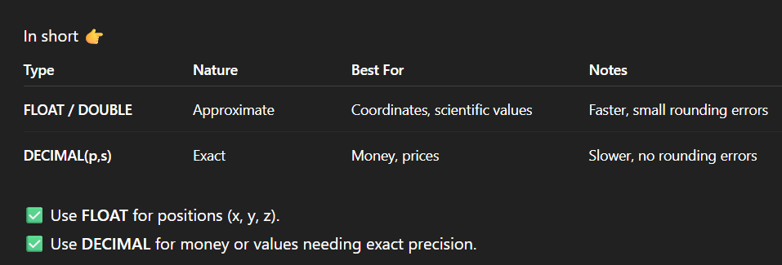
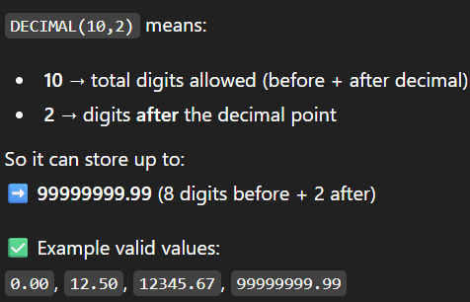
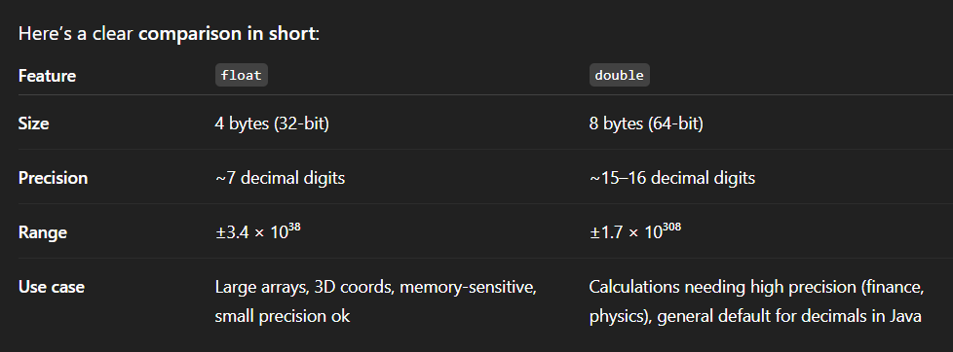

About Date and time Data type
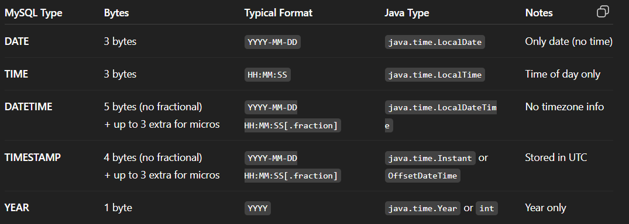
DateTime vs Instant
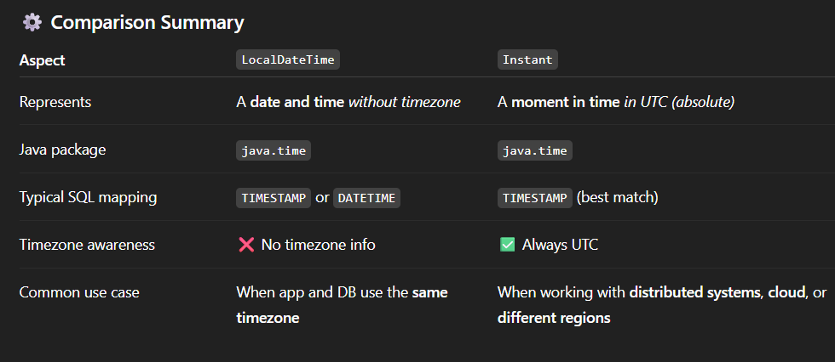

Snake_Case vs CamleCase
